# Chapter5 Results and Analysis

The main aim of this chapter is to present the simulation results for the transient stability assessment and voltage stability assessment. Based on the network modeling introduced in Chapter3 and the methodologies discussed in Chapter4, the impact of different generation configurations and operation scenarios on the system dynamic performance will be analyzed with bar charts, graphs, and scatter plot. A summary will be provided at the end of the chapter to conclude the findings of the research.

## 5.1 Impacts of generation configuration on power system transient stability with different HRESP locations and RES penetration levels

### 5.1.1 Transient stability performance for every test cases

As mentioned in Section 4.3, TSIs are calculated based on the angular response of all synchronous generators when a self-cleared three-phase fault occurs on the transmission lines. With the help of the PDF, the most probability of TSI is selected as the index standing for the transient stability for the testing cases, as shown in Figure 5-1. A larger value of TSI means a smaller rotor angle deviation between the generators in the system during the oscillation after being subject to contingencies, and subsequently, indicates a better transient stability performance. Likewise, a smaller value of TSI denotes the larger rotor angle deviation for the synchronous generators due to the fault and indicates the worse transient stability.

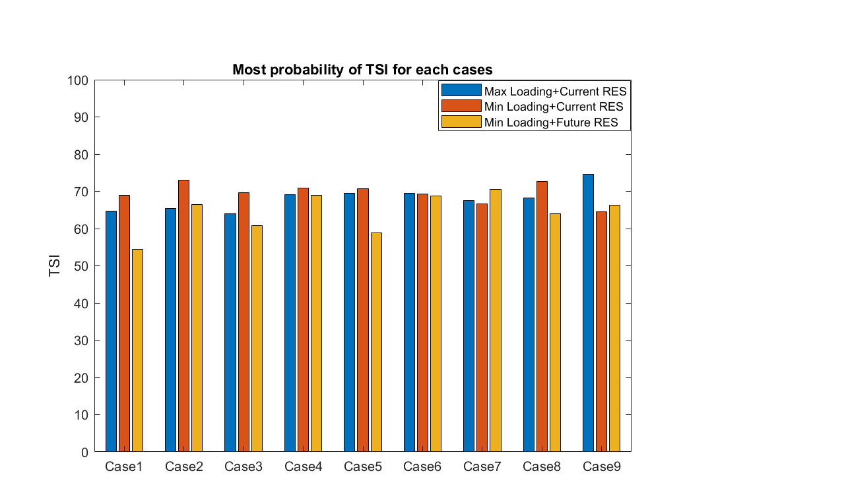

Figure 5-1: Most Probability of Absolute Values of TSI for Each Case

As shown in Figure 5-1, when the cases are simulated under the first type of scenario, illustrated in the blue columns (*Max Loading + Current RES level*), the system tends to have a slightly better transient stability performance with the HRESP located in Grid3 than HRESP located in Grid4 (comparing Case1, Case2, Case3 with Case4, Case 5, Case6). When both Grid3 and Grid4 are involved as the HRESP (Case7, Case8, and Case9), the transient stability mainly depends on the generation configuration, where the system working without the generation from the RES and local SGs will have the best transient stability (Case9), and the system with the RES integration the worst (Case7). By contrast, the effect of different generation configurations on the transient stability is limited when HRESP located in Grid3 and Grid4 individually.

Focusing on the cases under the second type of scenario, shown in the red columns (*Min Loading + Current RES level*), the impact of different generation configurations becomes obvious when HRESP placed in Grid4, where the replacement of RES generation with the local SGs would help the system to improve the transient stability performance (Case2). A similar situation was seen in the cases for the HRESP placed in both Grid3 and Grid4 simultaneously, where Case8 has the highest TSI value compared with Case7 and Case9, denoting the system could have a transient stability improvement with the involvement of local SGs. In contrast, the values of TSI are stabilized at around 70 no matter how the generation configuration changes when HRESP placed in Grid3 (Case4, Case5 and Case6), which means there is no significant effect of different generation configurations for Grid3 as the HRESP location.

Regarding the third type of scenario, demonstrated in the yellow columns, (*Min Loading + Future RES level*) the transient performance becomes more complicated with the variation of HRESP location and operation configuration. When HRESP placed in Grid4, the system operating with the help of local SGs rather than RES will have the best transient stability (Case2), following with the generation configuration that neither RES nor local RES is involved (Case3), and the penetration of RES would make the system have the worst transient performance (Case1). Nevertheless, the impact of generation configuration is opposite for the cases when HRESP placed in Grid3, giving the fact that the involvement of local SGs makes the system transient stability significantly weakened (Case5). Accordingly, it is enough to prove that the system transient stability will be affected by the location of HRESP and the generation configuration. In addition, A better transient stability can be obtained when RES in both Grid3 and Grid4 are integrated into the system (Case7). Likewise, there is a different phenomenon for the same operation configuration but under the first type scenario, where the transient stability with the participation of RES generation is the worst among the three operation configurations under the scenario of HESEP placed in Grid3&Grid4.

In order to investigate the impact of operating scenarios on transient stability performance, the resultant magnitudes of three different colors have been compared. From the first three sets of bars, which stand for the HRESP located in Grid4, it can be seen that the operating scenario would play a clear function in those cases. That is, the red bar always has the largest magnitude, implying that the system operating with *Min loading and Current RES* always has the best transient stability, even with the variation of generation configuration. In comparison, as for the test cases for HRESP placed in Grid3, no matter the system under which kind of the operating scenario, the difference of the system transient stability is slight, where the most probability of TSI usually is about 70, except Case5 under the *Min loading and Future RES* that the TSI value is less than 60. Additionally, when both Grid3 and Grid4 are treated as HRESP, the situation of the system transient stability can vary with the corresponding generation configuration. To be precise, when RES in Grid3 and Grid4 is integrated into the system, *Min loading and Future RES* could be the best operating scenario in terms of the system transient stability. While for the cases that plan to replace the generation of RES with the local SGs, the system under *Min loading and Current RES* has the best transient stability. As for the cases without the generation of RES and local SGs, the best operating scenario has turned to the *Max loading and Current RES*.

### 5.1.2 Impacts of different generation compositions on system transient stability

For the purpose of quantifying the specific extent that the different generation compositions can affect system transient stability, the percentage changes of the most probability of TSI are calculated and displayed in Figure 5-2. The cases without the production from RES and local SGs are treated as the base cases, the changes of TSI with RES and local SGs involvement are depicted by blue bars and red bars respectively. In the meantime, on account of the same production from RES and the locals, the effects of RES and the local can be compared concurrently. Since the larger TSI denotes better transient stability and the lower means the worse as mentioned before, the positive TSI percentage change suggests the system transient behavior becomes better and the negative TSI percentage change indicates the system transient behavior becomes worse.

According to Figure 5-2(a), when the system working under Scenario1 (*Max Loading and Current RES*), there is a significantly negative effect of RES and the local SGs on the system transient stability if both Grid4 and Grid3 are treated as HRESP, where close to 10% of TSI are decreased with either RES or the local SGs involved. In comparison, the system transient stability has been improved slightly with the generation of RES and the local SGs when HRESP located in Grid4 (1.25% and 2.34% respectively). As for HRESP located in Grid3, RES and the local SGs shows the opposite impact on the system transient stability. That is, the RES penetration will weaken it and the local SGs will improve it, but the effects of them are barely measurable. Additionally, in general, the impacts of the local SGs will lead to a better transient performance compared with RES, no matter the HRESP located in which grid. Furthermore, an interesting problem that emerged from the results is the impact of the local SGs when HRESP located in both Grid4 and Grid3. The involvement of the local SGs will have a positive effect on the system transient stability for HRESP located in Grid4 and Grid3 individually, but when both Grid4 and Grid3 are chosen as the HRESP location, the effect is reversed. The reason behind this may be the network topology, which was changed with the different generation compositions, and it also would be one of critical factors affecting the system transient behavior.

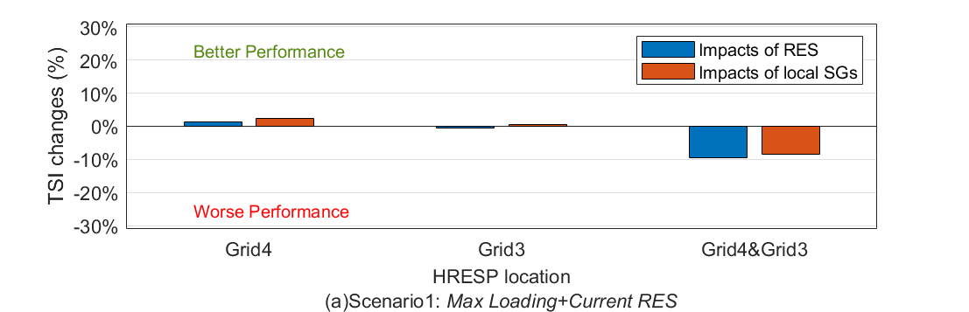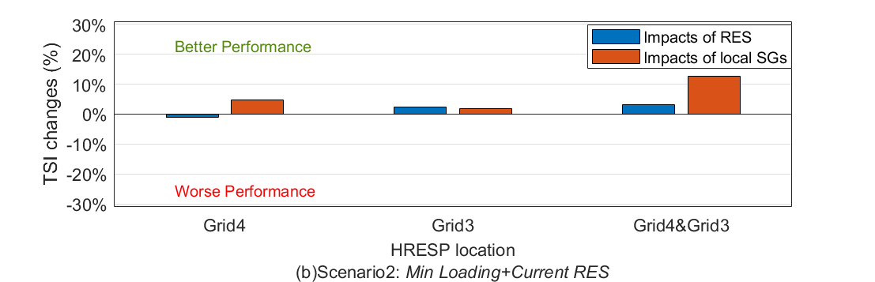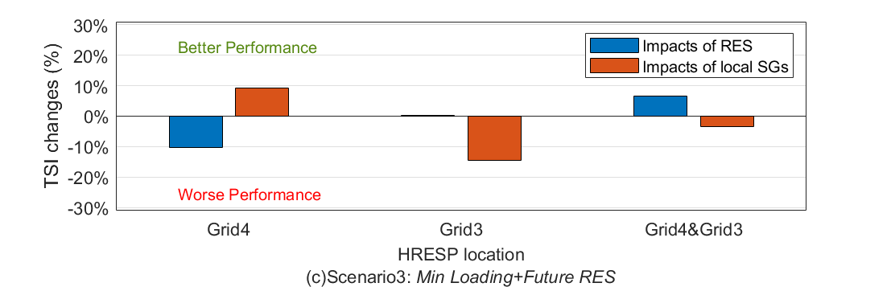

Figure 5-2: Most probability values of percentage change of TSI, with RES and local SGs involved respectively under different scenarios

Figure 5-2(b) illustrates the impacts of RES and the local SGs on the system transient stability under the scenario of *Min Loading and Current RES*. When HRESP located in Grid4, the integration of RES would have a lightly detrimental impact on the system transient stability (-1.15%), while the participation of the local SGs boosts the 4.73% the system transient stability performance. When HRESP placed in Grid3, better transient stability performances were observed with the function of RES and the local SGs individually, where the influence of RES (2.45%) is slightly higher than that of the local SGs (1.88%). A similar situation was seen for the HRESP located in both Grid3 and Grid4. The generation of RES and the local SGs have a positive influence on the system transient stability, where the involvement of the local SGs help the system make a remarkable improvement (12.56%). Overall, under the *Min Loading and Current RES* scenario, the involvement of RES and the local SGs is beneficial for the system transient stability in most cases, except the penetration of RES only from Grid4.

Regarding Scenario3 (Min Loading and Future RES), it can be seen form Figure 5-2(c) that the effect of RES and the local SGs on the system transient stability became more significant. When HERSP located in Grid4, an obviously detriment effect can be observed from the integration of RES, about 10% system transient stability worsen, but if the same amount of power is generated from the local SGs, the system transient stability could be improved nearly 10%. However, the opposite effects could be noticed when both Grid4 and Grid3 are treated as HRESP, where the generation of RES has led to an improvement and the involvement of the local SGs has resulted in a deterioration on the system transient stability. Moreover, for the system with HRESP located in Grid3, the positive effect of the penetration of RES is negligible, while the system transient stability is deteriorated significantly by the participation of the local SGs (-14.5%). All in all, both the involvement of RES and the local SGs could lead to better or worse transient stability performance with the variation of HRESP location.

Focusing on the change of the system transient stability performance, there is no regular effect for the involvement of RES or the local SGs, and this may be explained by the inertia, which usually is provided by the synchronous generators. A lower inertia of the system will bring the worse transient stability and vice versa. When the system is working with the integration of RES or the local SGs, the production of synchronous generators in the grid would be commensurately reduced and some of them with high margin costs will be decommitted, which results the inertia of the system reduced. Considering that the RES could have a positive effect on the system transient stability and the local SGs also could remedy the reduced inertia to some extent, there is a competition between the negative effect of the lower inertia and the positive effect from RES or the local SGs. Accordingly, the system could perform a better or worse transient stability behavior with the involvement of RES and the local SGs.

### 5.1.3 Transient Stability Analysis of Fault Locations

In order to avoid the loss of detailed information for transient stability assessment, the calculated TSIs of every fault location have been shown in Figure 5.2 as heatmaps. As mentioned in Section 4.3, self-cleared three-phases faults are tested in the middle of every transmission line one by one. There are 200 transmission lines in the network and they are numbered from PCC1 to PCC200. The x-axis of heatmaps shows the fault location, which the number of lines happens a short circuit, and the y-axis lists the testing cases. The color bar displays the colors and their corresponding TSI values. Since the lower TSI value comes out of the larger rotor angle deviation, representing the weaker transient stability for the system, and the larger TSI value means the smaller rotor angle deviation, which stands for the better system transient stability. Therefore, it is reasonable to color the lower TSI value with red and higher TSI value with blue.

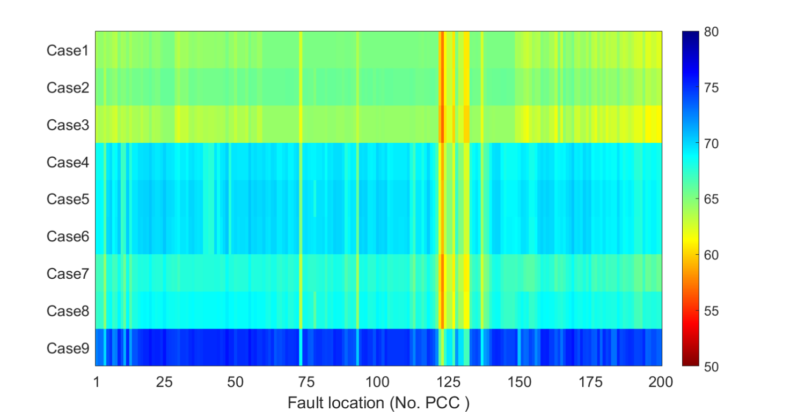

1. Scenario1: Max Loading + Current RES level

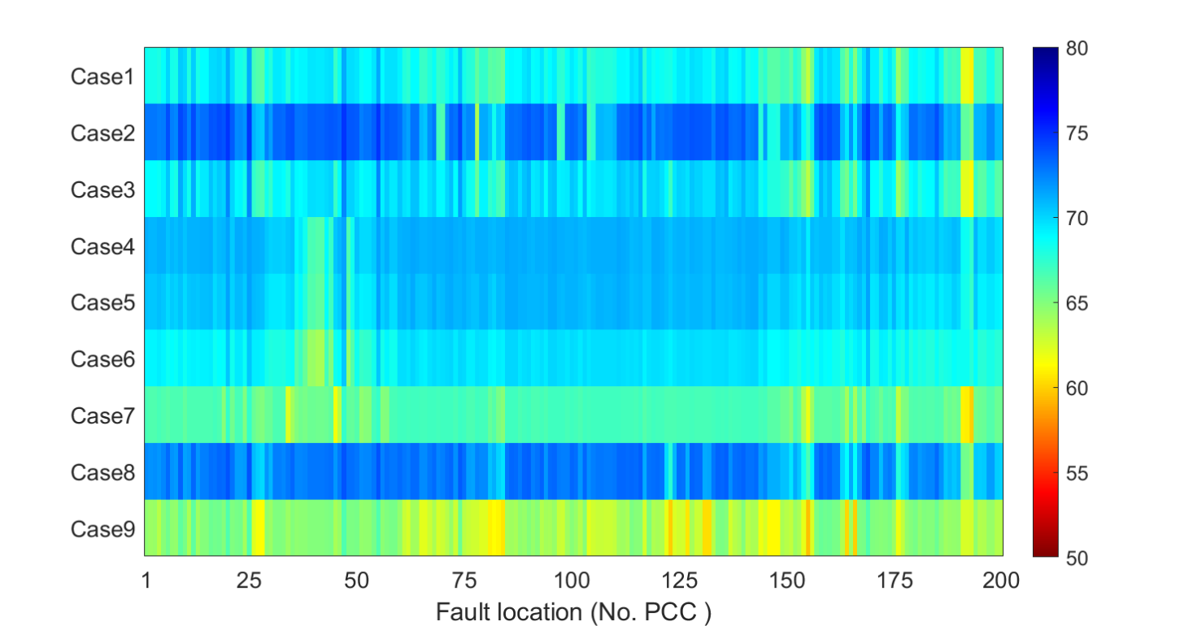

1. Scenario2: Min Loading + Current RES level

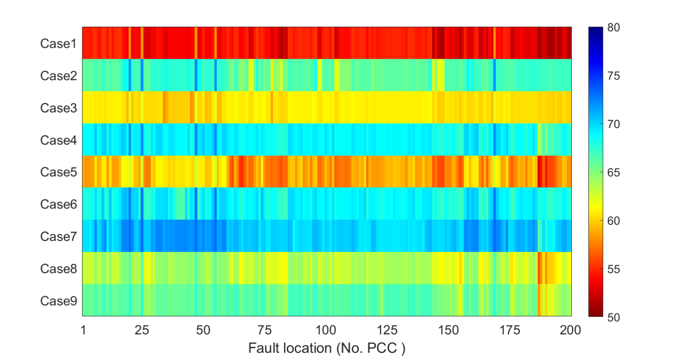

1. Scenario3: Min Loading + Future RES level

Figure 5-3: Heatmaps of TSI for every fault location under different scenarios

According to Figure 5-3(a), the transient performance is generally good for the system under the scenario of Max loading and Current RES level because the most area are shown in green and blue color, which means the system has a good transient stability for these faults. However, it is obvious that there are several fault locations that will cause terrible transient performance. To be precise, they are PCC123, PCC122, PCC127, PCC131 and PCC132, corresponding to LN67_B78_3_B112_3, LN66_B77_3_B110_3, LN71_B83_3_B208_3, LN75_B94_3_B140_3 and LN76_B95_3_B78_3 in the network, and these dangerous transmission lines due to the worse transient stability are located in Grid3. Therefore, the system operators should set better protection equipment for these lines in order to guarantee the operation of the power system.

The system transient performance under the scenario of Min loading and Current has been visualized in Figure 5-3(b). In general, the system transient stability is good like the first type of scenario. Almost for every fault location, the TSIs are over 60. The short circuits that worth attention and care occur in Case9 (without the generation from RES and local SG of Grid3&Grid4). The specific fault locations are PCC123, PCC155 and PCC166, where the TSIs are lower than 60. The lines corresponding to these fault locations are LN74_B94_3_B138_3, LN155_B188_2_B190_2, and LN166_B238_3_B188_2 respectively. LN74 is located in Grid3, while LN155 and LN166 are located in Grid2. Through comparing it with Scenario 1, it can be found that the critical transmission lines have changed. Accordingly, it can be concluded that the critical transmission lines will vary with the change of generation configuration and operating scenario.

As for the scenario of Min loading and Future RES level, Figure 5-3(c) illustrates the transient stability performance of every fault location. A fairly terrible situation was seen in Case1 compared with the others. Most areas of Case1 are colored with red, which means the system transient stability becomes bad when the RES plants are working and the local SGs are closed. Similarly, Case5 would be the second-worst case in terms of transient performance, giving the fact that the major of fault locations are labelled with orange. Accordingly, these two kinds of generation configuration are not recommended to the system operators when the system operating under Min load and Future RES, for the purpose of keeping a good system transient stability.

### 5.1.4 Transient Stability Analysis of RES Penetration level

Due to the variation of operating scenario and generation configuration, the RES penetration level is different from case to case. Different RES penetration level may lead to the different transient stability performance for the system. Accordingly, the relationship between the RES penetration level and transient stability will be analyzed in the following discussion.

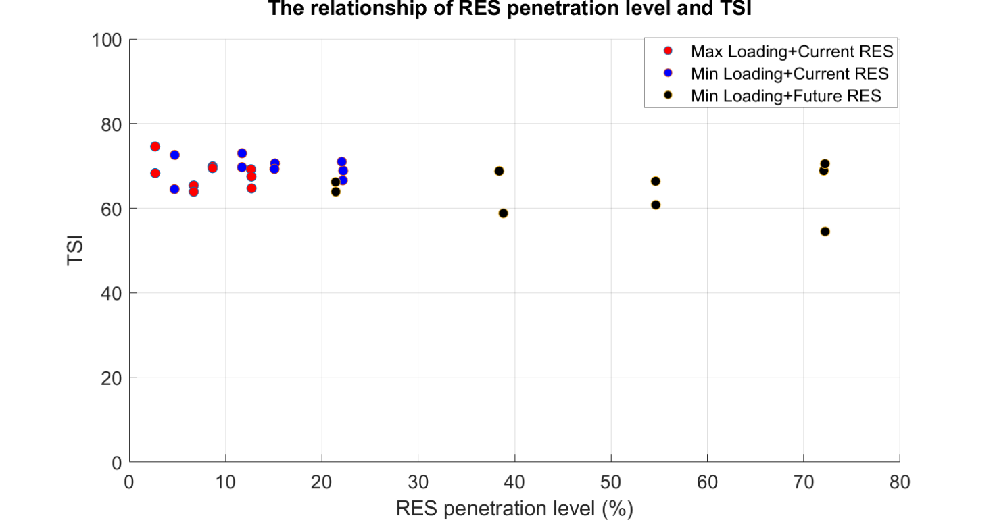

Figure 5-4: The relationship between TSI and RES Penetration Level for Test Cases

The RES penetration level of the test cases has been calculated according to Equation (4.3) introduced in Section 4.3, and then, a scatter plot has been created for the relationship between the most probability of TSI for test cases and the corresponding RES penetration level, as shown in Figure 5-4. It can be seen that the TSI fluctuates between about 60 and 80. Compared with the Current RES level, Future RES plan could make the RES penetration level of the system increased dramatically, with the maximum RES penetration level of over than 70%, which means the major part of load demand could be covered by the RES. However, the lowest TSI also occurs in the operating scenario of Min Loading and Future RES when the RES from Grid3 and Grid4 are integrated in the system, where the TSI drops to 55. This may be explained by the countereffect of more RES integration. That is, the system transient stability could be improved by the dynamic performance of RES on the one hand, and on the other hand, higher RES penetration also implies the more disconnection of synchronous generators, which has a detrimental effect on the system transient stability.

Except the RES penetration level of the system, there must be some other factors affecting the system transient stability, since it cannot find out an obvious relationship between the TSI and the RES penetration level in Figure 5-4, neither positive correlation nor negative correlation. For a RES penetration level, there could be two or more TSI values for the system, which means the system transient stability could not be determined by the RES penetration level simply. Different generation configurations imply different network topologies, including the distance of transmission lines, the number of synchronous generators involved, and so forth, which also are critical to the system transient stability. Therefore, more factors should be considered in the future analysis.

## 5.2 Impacts of generation configuration on power system voltage stability with different HRESP locations and operating conditions

### 5.2.1 Voltage Stability Analysis with PV curves

In this part, the system voltage stability has been investigated with the PV curves of their critical bus. As mentioned in Section 4.1, the voltage of the busbars will decrease with the increment of the load demand in the system until the voltage of one busbar collapse. The critical point of the PV curve corresponds to the maximum load demand that the system could support. Accordingly, the larger gradient of the PV curve means the system collapse faster with the increasing load, resulting in the smaller critical load demand. While the PV curve has a smaller slope, the system can cover more active power demand in the stable operating conditions. The PV curves for each operating scenario are analyzed in the following. Note the result may have errors due to the step size of the simulation. The smaller step size could make the calculation closer to the stability limit. However, higher accuracy of the result is obtained with the expense of high computational effect. Thus, there is a compromise between the accuracy and the computational time for the step size.

First of all, regarding Scenario1 (Max Loading and Current RES), the PV curves of the testing cases are plotted in Figure 5-5. According to the HRESP locations, 9 PV curves are divided into 3 subfigures for better visualization, which are Grid4 only, Grid3 only, Grid4 and Grid3. It can be observed that the PV curves in the second subfigure generally have comparatively large critical load demands, around 1.7 p.u., no matter how the generation configurations change. By contrast, when HRESP placed in Grid4 only or both Grid4 and Grid3, the maximum load demand is lower than 1.5 p.u. for the system in Case1, Case3, Case7, and Case9. In other words, the system will collapse faster without the generation from their local SGs. In addition, for each set of PV curves, the system working without the RES and local SGs has the smallest critical load demand, and the system with the involvement of the local SGs the largest. This means the generation configuration affects the voltage stability, and enabling the local SGs to replace RES to generate the same amount of power will have a positive effect. In the meantime, it can be found that the critical busbar could occur at different locations with the change of generation configuration. Under this scenario, B207_4 and B150_2 have the probability to become the critical busbar depending on the cases.

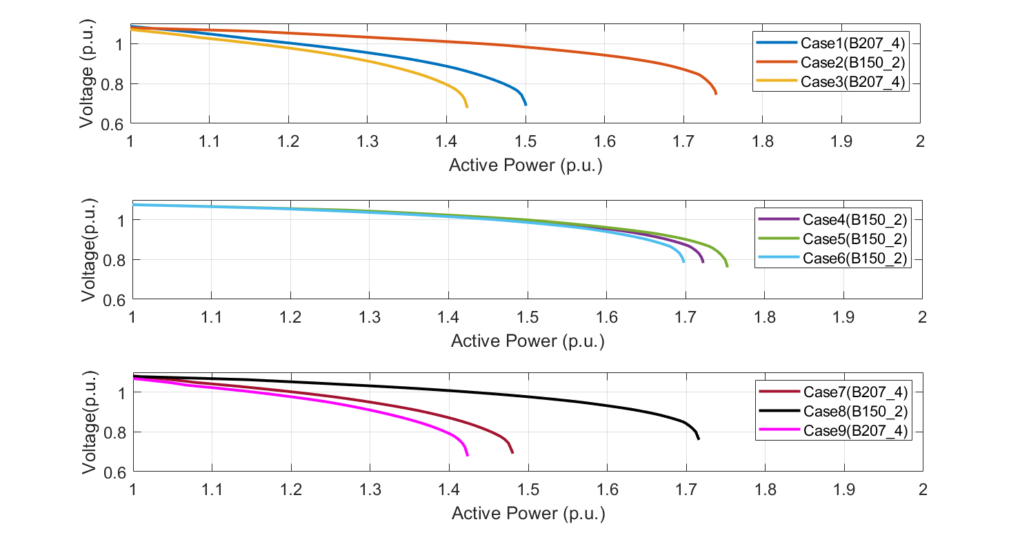

Figure 5-5: PV Curves for cases in *Max Loading and Current RES* Scenario

Secondly, Figure 5-6 illustrates the PV curves under Scenarion2 (Min Loading and Current RES) in the same way as Scenario1. The best voltage stability belongs to Case5, where the slope of the PV curve is the lowest one among the testing case. In comparison, the system of Case9 has the worst voltage stability, which would collapse when the active power demand rises to 1.36 p.u. Additionally, the effect of generation configuration shows the same trend as it in Scenario1. That is, for the cases in the same HRESP location but different generation configuration, the involvement of the local SGs instead of RES usually makes the system have the best voltage stability, following with the system working with RES but no local SGs, and when neither RES nor local SGs involved the system has the worst voltage stability. In terms of the effect of HRESP location, the cases for different HRESP location but the same generation configuration are compared. There is not a significant difference between the HRESP in Grid4 and it in Grid3. But when both Grid4 and Grid3 are treated as the HRESP, the critical load demand is considerably reduced compared with the other two options of HRESP location. In conclusion, operating without the generation of RES and local SGs and placing HRESP in both Grid4 and Grid3 are not recommended for the system operators in terms of the system voltage stability.

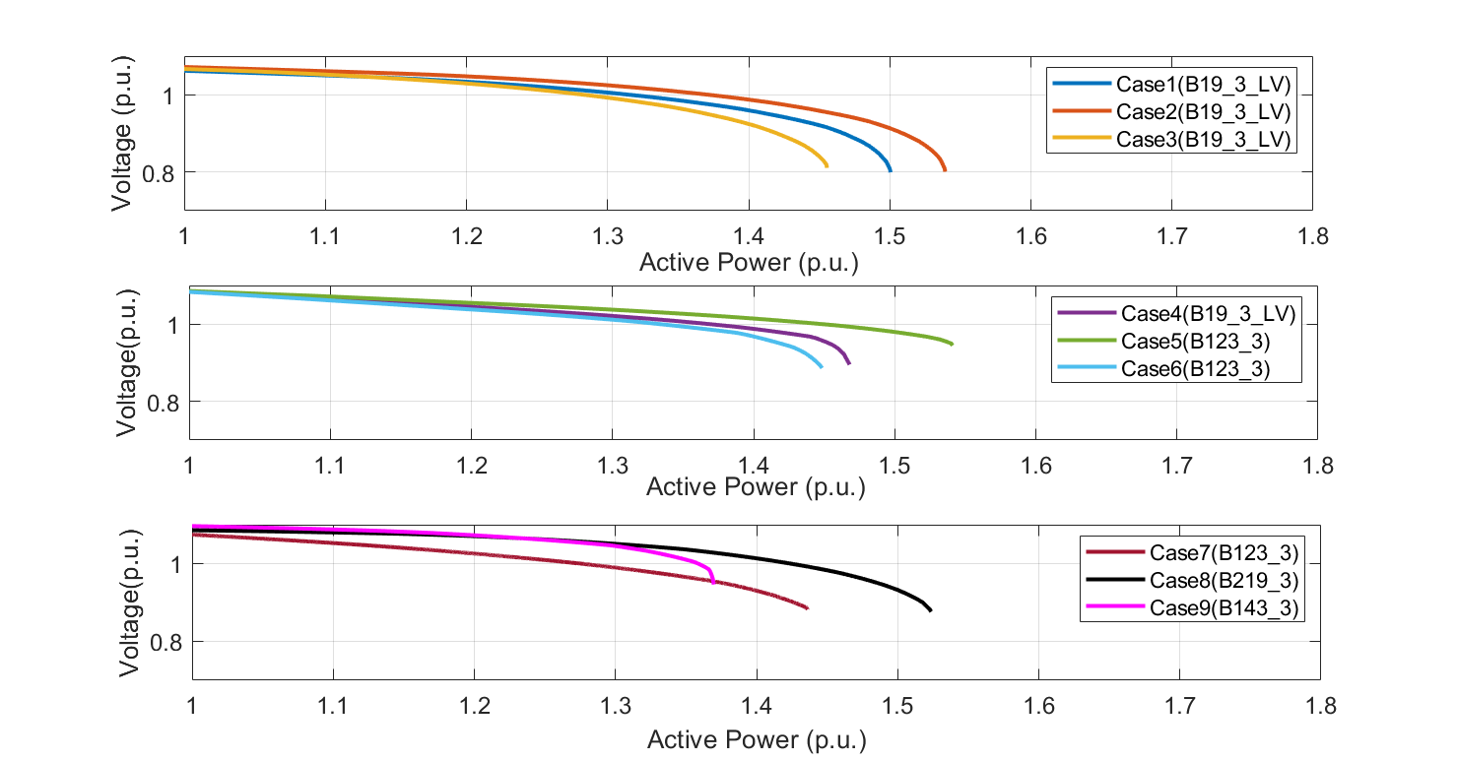

Figure 5-6: PV Curves for cases in *Min Loading and Current RES* Scenario

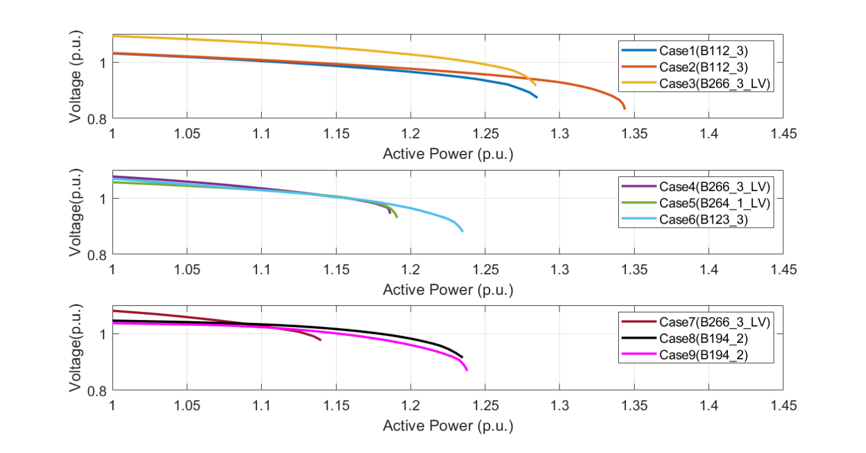

Figure 5-7: PV Curves for cases in *Min Loading and Future RES* Scenario

Moreover, the PV curves for the system working in Scenario3 are plotted in Figure 5-7 (Min Loading and Future RES). For the HRESP located in Grid4, a generally good system voltage stability can be obtained compared with the other HRESP locations. The best one is Case2 with 1.34 p.u. critical load demand, the system of Case1 and Case3 could cover 1.28 p.u. critical load demand. While a different situation was seen for the HRESP located in Grid3, where the larger critical load demand (1.24 p.u.) belongs to the system which operates without the generation of RES and local SGs (Case6), and the system in Case4 and Case 5 has the smaller critical load demand, about 1.19 p.u.. As for the HRESP located in both Grid4 and Grid3, another different situation was seen. The system in Case8 and Case9 has the similar voltage stability, which will collapse when the active power load arrived at 1.24 p.u.. In Case7, representing the RES from Grid4&Grid3 are involved and the local SGs are closed, the maximum active load demand that the system could support only is 1.14 p.u., which also is the worst one under the scenario. All in all, the voltage stability performance varies with the different generation configuration, and placing HRESP in Grid4 is recommended in this scenario due to the larger critical load demand.

### 5.2.2 Voltage Stability Analysis with Load Margin

As discussed in Section 4.1, the load margin is one category of voltage stability index, which stands for the maximum extra active power load the system can support over the normal working scenario, so the critical active power load minus the initial load demand is the load margin. The load margins for nine testing cases and three operating scenarios are calculated and plotted as a bar chart shown in Figure 5-8. And in order to analyze the effect of the operating scenario on the system, the magnitude of three different color column bars has been compared and analyzed.

According to Figure 5-8, significant different load margin levels for different operating scenarios can be observed. To be precise, the blue solid bar (*Max Loading + Current RES*) always has the highest magnitude, varying from 5600 to 8600 MW. This means that the system under the *Max loading and Current RES* scenario could support the most load increment before the voltage collapse, representing the best voltage stability performance. The next is the red solid bar (*Min loading and Current RES*), where the load margin could vary from 2500 to 3600 MW. The yellow ones, standing for the *Min loading and Future RES* scenario, usually has the lowest magnitude. The most terrible load margin occurs in Case7 under Scenario3, which is lower than 1000MW. This indicates the voltage stability is fairly weak and the system would be fragile with the load increment. Through the comparison between Scenario1 and Scenario2, it can be found that with the same RES level, working for the more loading level could be beneficial for the voltage stability performance. And when comparing the load margin of Scenario2 and Scenario3, where the loading level is the same but the RES level is different, since the system working with the Current RES level has the larger load margin, it can be concluded that for the more integration of RES will have an adverse effect on the system voltage stability.

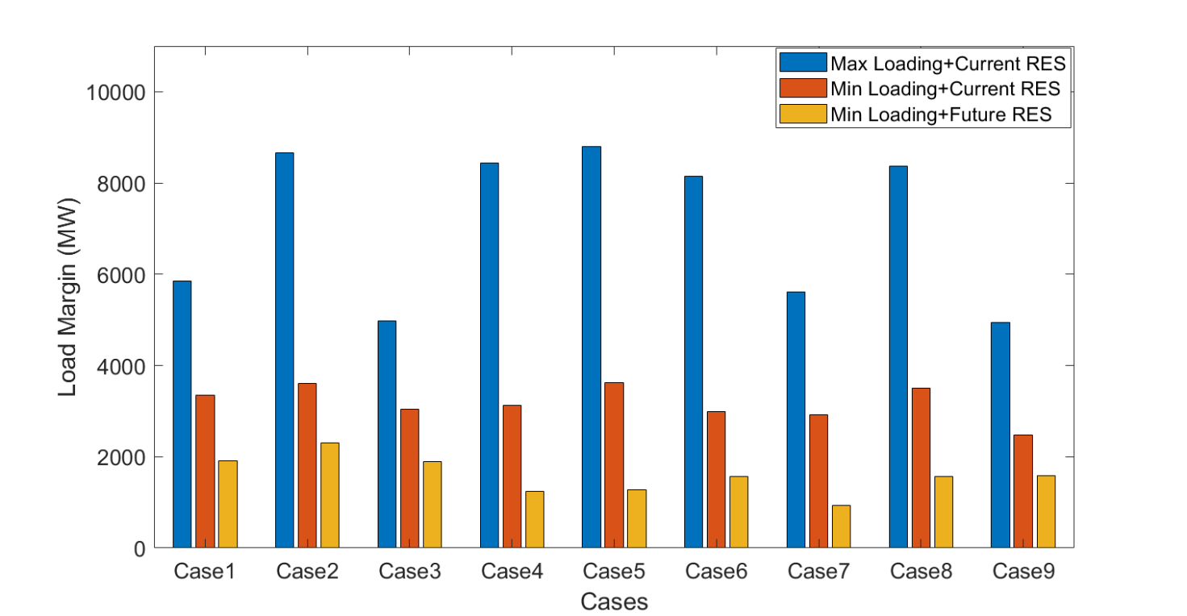

Figure 5-8: Load Margins of Every Test Case

### 5.2.3 Impacts of different generation compositions on system voltage stability

The specific impacts of the penetration of RES and the involvement of the local SGs on the system voltage stability are assessed by calculating the percentage change of the load margin, which are displayed in Figure 5-9. The cases tested without the generation of RES and the local SGs (Case3, Case6, Case9) are treated as the base cases, the percentage change of the load margin caused by the integration of RES and the local SGs are depicted in different colors. Given that a higher load margin represents better voltage stability and a lower load margin represents worse voltage stability, the positive change of load margin denotes the participation of RES or the local SGs improved the voltage stability for the system, and the negative change of load margin stands for the voltage stability was deteriorated under the impact of RES or the local SGs.

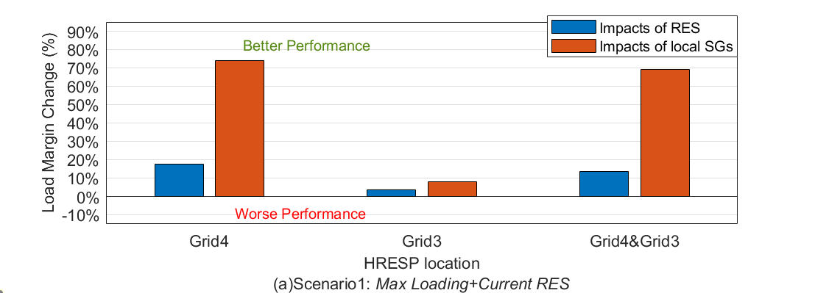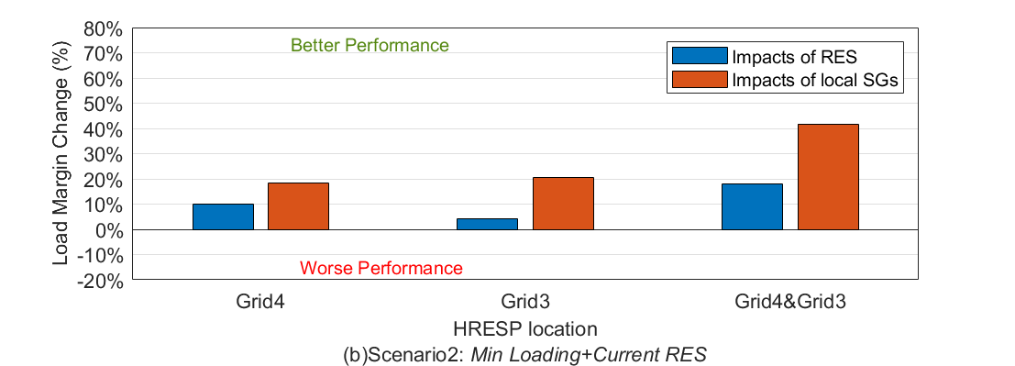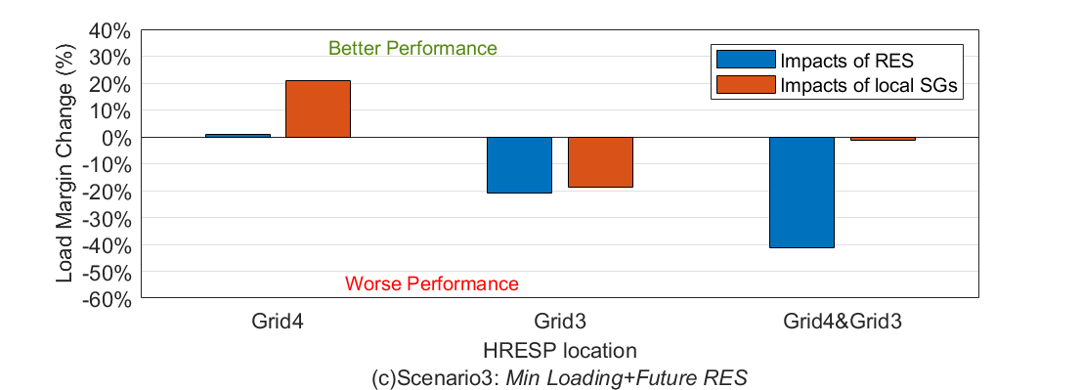

Figure 5-9: Percentage Changes of Load Margin, with the impact of RES and local SGs respectively, under different scenarios

Firstly, concentrating on the load margin change in Scenario1 (*Max loading and Current RES*) shown in Figure 5-9(a), the involvement of RES and the local SGs would improve the voltage stability for the system. The extents of the impact for HRESP located in Grid4 only and HRESP located in both Grid4 and Grid3 is similar, where around 70% improvement of the system load margin could be found under the function of the involvement of the local SGs, and the integration of RES would raise about 15% the system load margin. In comparison, the effect of different generation composition on voltage stability is much smaller for HRESP located in Grid3, the positive effects of RES and the local SGs are 3.5% and 7.9% respectively. In addition, by comparing the magnitude of load margin changes, it can be found that the extents that the local SGs would impact on voltage stability are regularly higher than that of RES.

Secondly, focusing on Scenario2 (Min loading and Current RES), as shown in Figure 5-9(b), the situation of the impact of the different generation compositions is similar to Scenario1 to some extent. That is, all the system load margins have been increased under the impact of RES and the local SGs. The largest improvement in voltage stability (41.8%) is carried by the involvement of the local SGs when HRESP located in both Grid4 and Grid3, which is about the twice time of the extent of the RES impacted. And the contribution of the local SGs also is nearly the twice time of RES when HRESP located in Grid4, which is 18.39% and 9.88% respectively. As for HRESP placed in Grid3 only, the generation of the local SGs could improve about 20% increment of the load margin, but the involvement of RES just has a moderate effect on the voltage stability performance, 4.35% of the load margin increased. It could be concluded that under the scenario of Min Loading and Current RES, the positive effects of the local SGs always are much higher than the penetration of RES.

Moreover, regarding Scenario3 (*Min Loading and Future RES*), Figure 5-9(c) reveals the impacts of the involvement of RES and the local SGs on the system voltage stability. There are some unexpected outcomes when HRESP is located in Grid3 and when HRESP is located in Grid4 and Grid3 simultaneously, where the impact of participation of different generation compositions would decrease the load margin. 40% load margin would be declined by the penetration of RES from Grid4 and Grid3 together, while the negative effect caused by the local SGs in the same HRESP is negligible. As for HRESP located in Grid3, the participation of RES and the local SGs would cases a similar adverse influence on the voltage stability performance, around 20% load margin decreased. When Grid4 chosen as the HRESP location, the voltage stability has been improved remarkably by the generation from the local SGs (21%), but the positive effect of RES penetration is limited. Hence, when the system working under the scenario of *Min Loading and Future RES*, the involvement of RES and the local SGs could cause better or worse voltage stability with the variation of HRESP, and the specific impacts of them also are varied.

In summary, this section quantified and discussed the impacts of different generation compositions on power system voltage stability under different kinds of scenarios. When the power system working in the *Current RES* level, the participation of RES and the local SGs always have a positive effect on system voltage stability. But for the *Future RES* scenario, the system voltage stability may be deteriorated by the involvement of RES and the local SGs. Accordingly, different scenarios may lead to different and even opposite impacts of generation compositions on the system voltage stability. Furthermore, closer inspection of the figures shows the specific impact of the penetration of RES and the generation of the local SGs on the system voltage stability would vary with the change of HRESP location. Therefore, the conclusion is that the impact of the involvement of different generation compositions on the voltage stability performance is varied, depending on the HRESP location and the operating scenario.